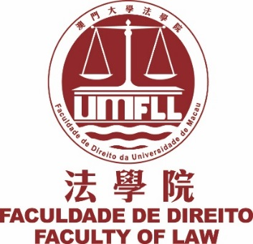
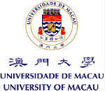

Master and Bachelor of Law Seminar in Portuguese Language
Eighth Seminar on the Operation of Games of Chance and Contracts in Special:

Privacy in Casinos

Francisco Sá da Bandeira:
Privacy in the Gaming and Hospitality Industries: a Practical Approach​

Denis Halis:
Gambling With Your Privacy: Casino Surveillance and Loyalty Programs

Sten Idris Verhoeven:
Privacy and Electronic Surveillance in Casinos

Date: 22 March 2017
Time: 18:45-20:30
Venue: E4-G062

Language: English

All are welcome

Organized by Centre for Law Studies, Faculty of Law, University of Macau

